FRIENDS OF THE DERBY VOLUNTEER PROGRAMME
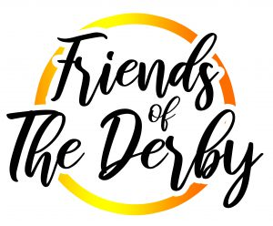

WHY DO PEOPLE VOLUNTEER?
People volunteer for a variety of reasons:
- Work experience
- Reference/testimonial
- A challenge
- A sense of achievement
- To learn new skills
- Share their skills and knowledge
- Improve the quality of peoples’ lives
- Contribute towards the community
- Opportunities for personal development/growth
- Make new friends
Could you spare one hour a week for 6 weeks? We are looking to recruit a team of volunteers to help us to rebuild our outstanding student development programme.
We know how important experiences are for our students, so we are asking for your help. Can you support us to deliver an enrichment activity?
You may not feel able to run an activity by yourself. If this is the case, you could support a member of staff or a student leader to run an activity. Alternatively, you could help with our reading programme, lunchtime games club or gardening and maintenance team. All volunteer posts are subject to a Disclosure & Barring Service Check (DBS) and suitable references being obtained
Please complete the expression of interest form if you’re interested in becoming a Friends of The Derby volunteer
Name: ___________________________________________________
Email:____________________________________________________
Telephone: _______________________________________________
I am interested in volunteering to… ____________________________________________________________________________________________________________________________________________________________________
I am interested in becoming a Friends of The Derby Volunteer because … ______________________________________________________________________________________________________________________________________________________________________________________________________________________________________________________

