The Derby High School
Weekly Roundup
WC 15TH May 2023

A MASSIVE WELL DONE TO ALL THOSE INVOLVED WITH TWENTY! AT THE MET THEATRE. WHAT A FANTASTIC EVENING
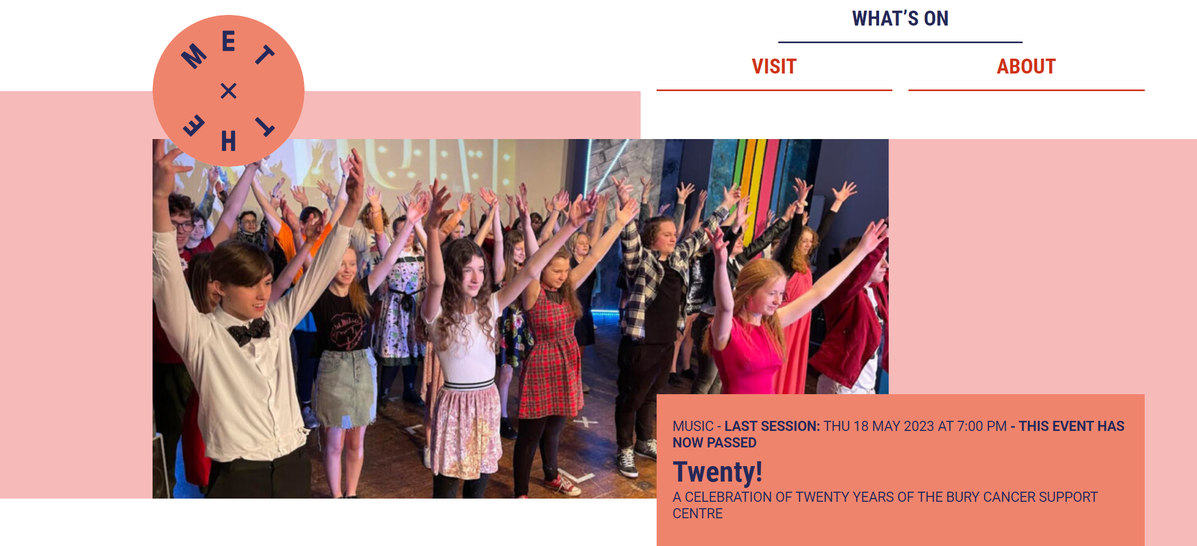

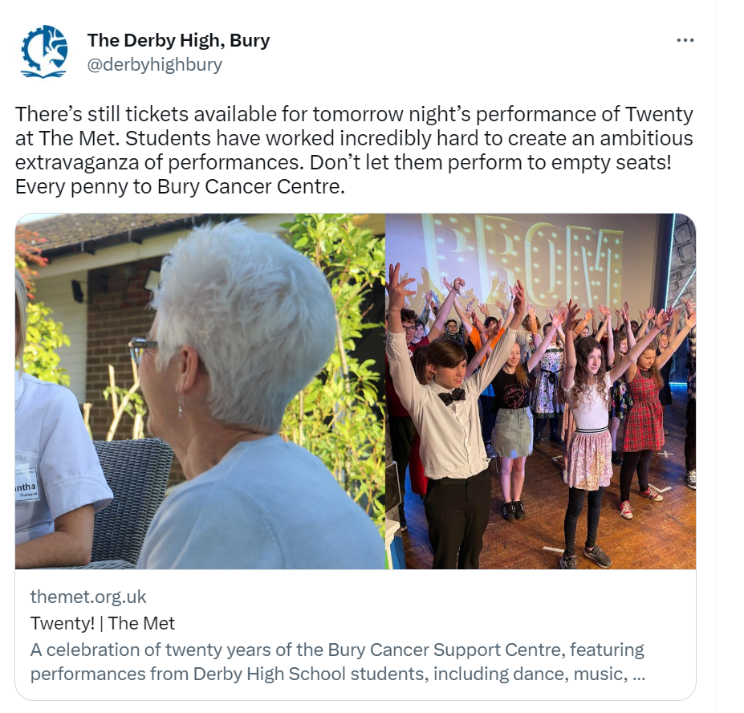
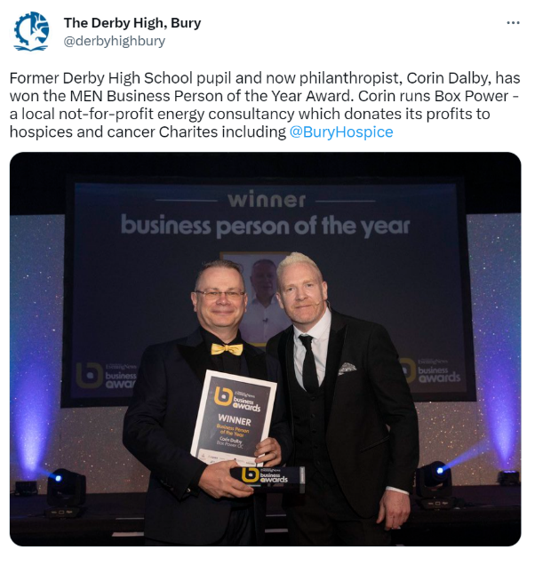

CONGRATULATIONS AVINNA!
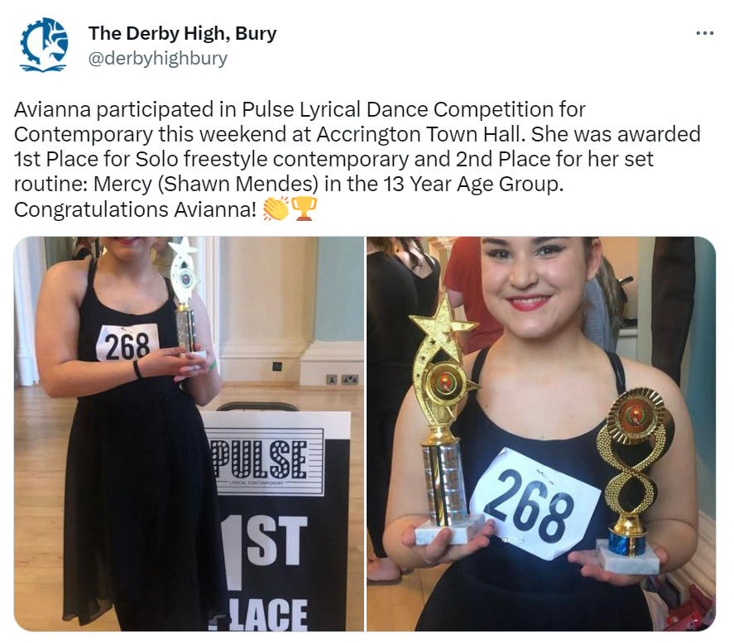

#MENTALHEALTHMATTERS

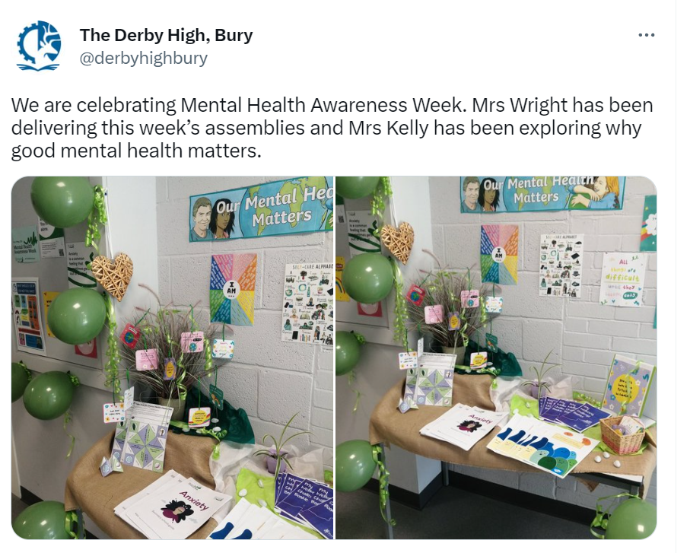

GOOD LUCK TO ALL YEAR 11 STUDENTS STARTING THEIR GCSE EXAMINATIONS THIS WEEK. WE OFFER OUR CONTINUING SUPPORT AND GUIDENCE

#INSPIREDTOMAKEADIFFERENCE
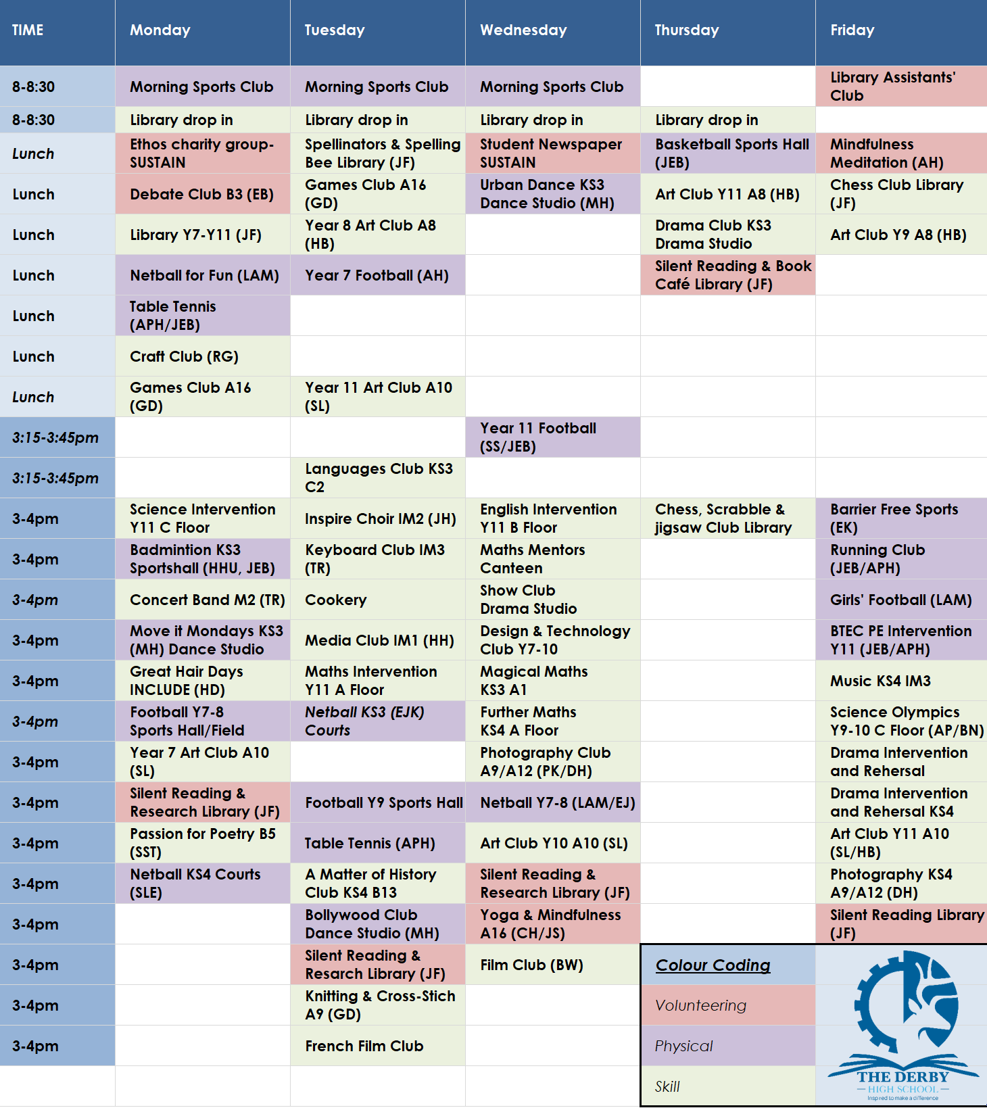
You can download all The Derby Diploma posters and timetable using this LINK

