The Derby High School
Weekly Roundup
WC 1ST May 2023

WELL DONE TO OUR NEW PREFECTS AND SENIOR PREFECTS!

#REALWORLDEXPERIENCES

THE NEW SUMMER TERM PE ENRICHMENT TIMETABLE IS HERE! WE HOPE ALL STUDENTS GET INVOLVED.
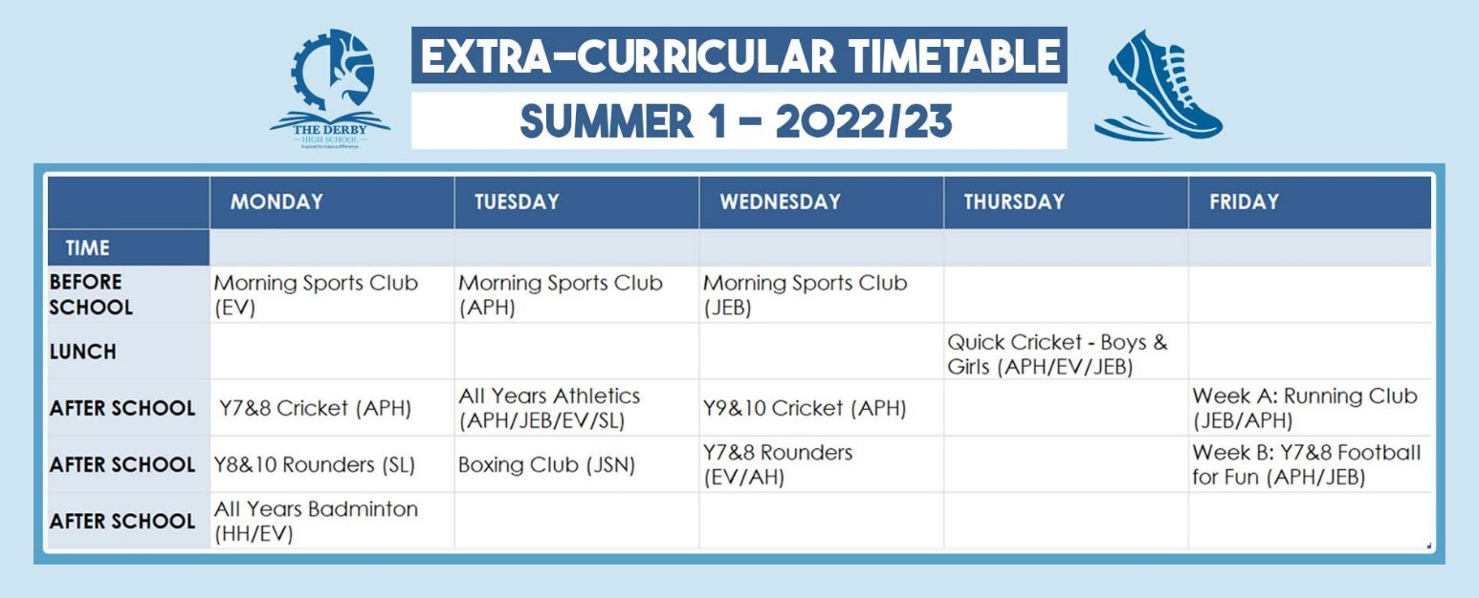

3 NEW ENRICHMENT ACTIVITIES ARE COMING TO THE DERBY!
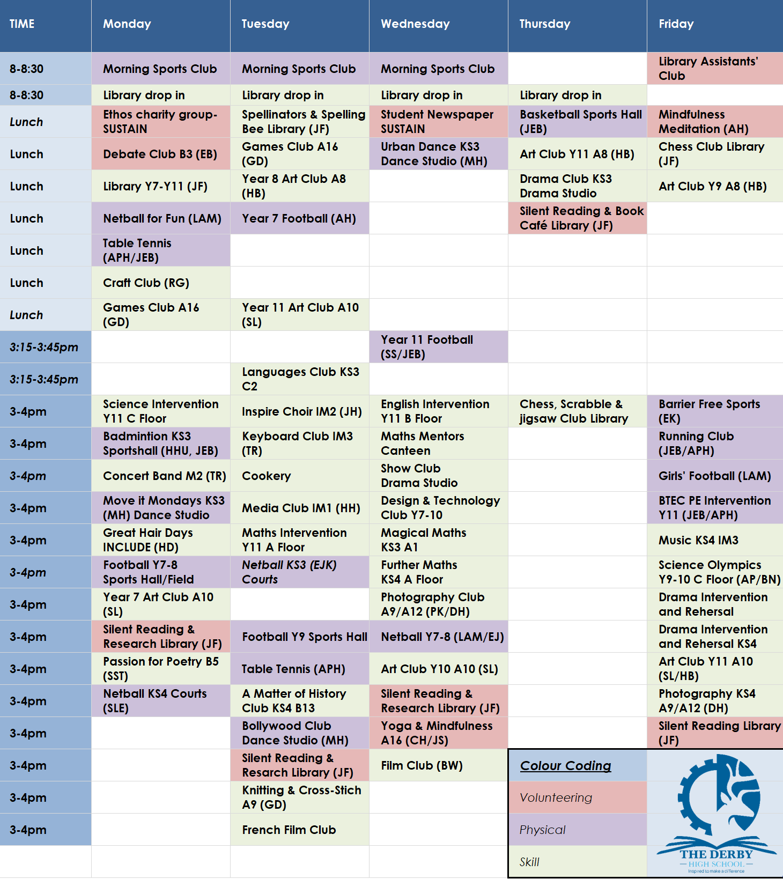
You can download all The Derby Diploma posters and timetable using this LINK

