The Derby High School
Weekly Roundup
WC 22nd May 2023
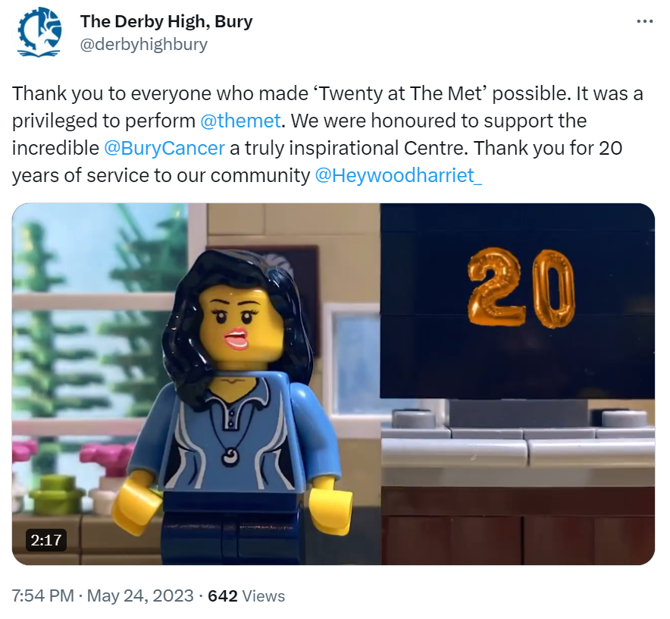
THE FULL TRAILER FOR TWENTY AT THE MET IS NOW AVAILABLE TO WATCH ON OUR TWITTER. THANK YOU AGAIN TO ALL THOSE INVOLVED!

WELL DONE 8R!
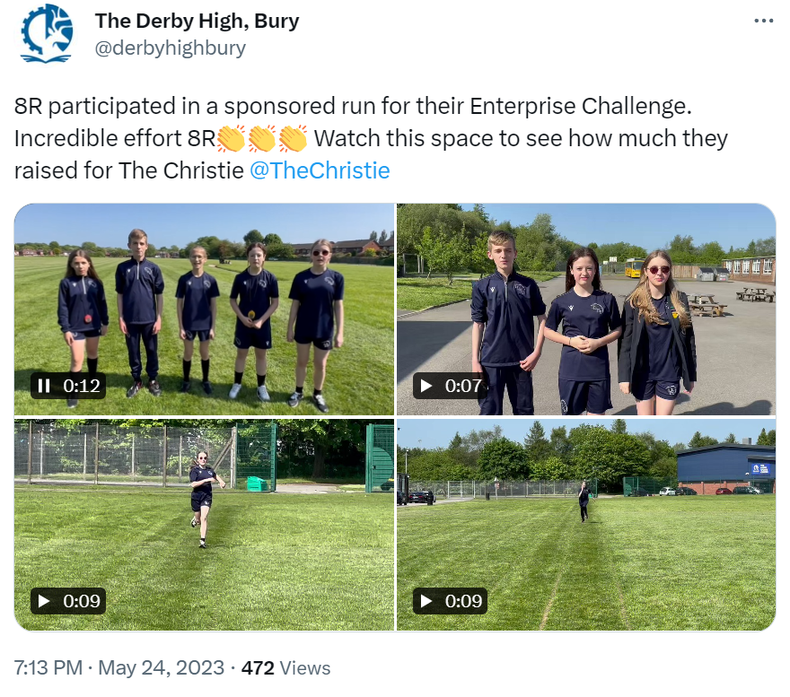

THANK YOU AGAIN DANI FOR THIS EXCITING OPPORTUNITY FOR OUR STUDENT LEADERS

#MENTALHEALTHMATTERS

#THEDERBYDIPLOMA

GOOD LUCK TO ALL YEAR 11 STUDENTS STARTING THEIR GCSE EXAMINATIONS THIS WEEK. WE OFFER OUR CONTINUING SUPPORT AND GUIDENCE

#INSPIREDTOMAKEADIFFERENCE
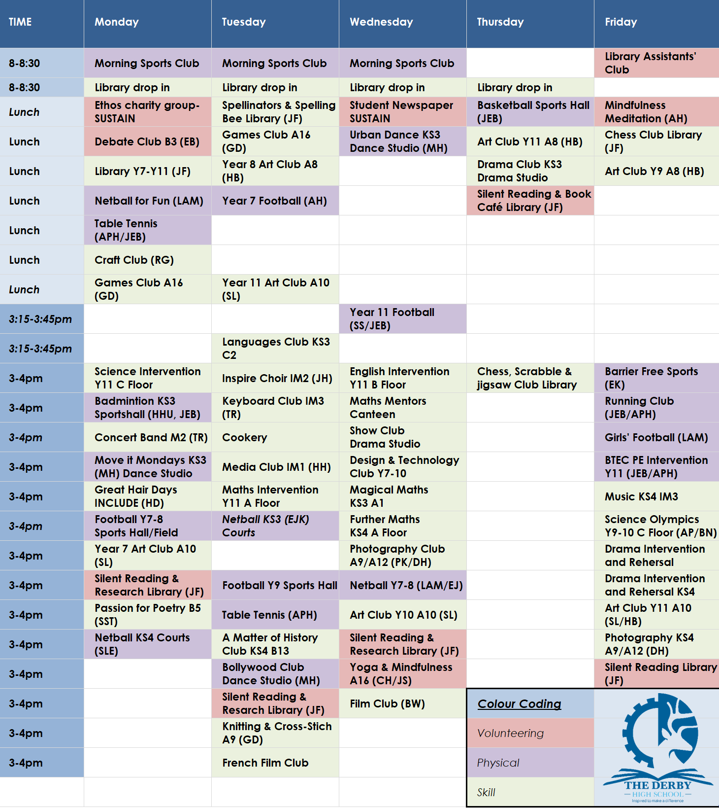
You can download all The Derby Diploma posters and timetable using this LINK

