The Derby High School
Weekly Roundup
WC 26th June 2023

WE WELCOMED A VERY SPECIAL GUEST THIS WEEK! ANDY BURNHAM PAID THE DERBY A VISIT TO SEE ALL THE EXCELLENT THINGS GOING ON IN OUR SCHOOL.

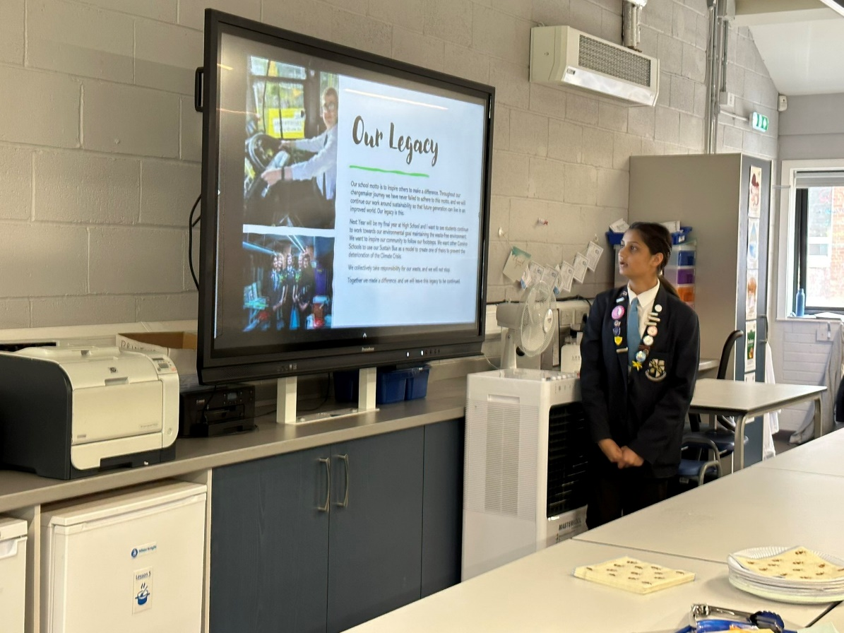

WELL DONE TO OUR DERBY DANCERS!

#REALWORLDEXPERIENCES

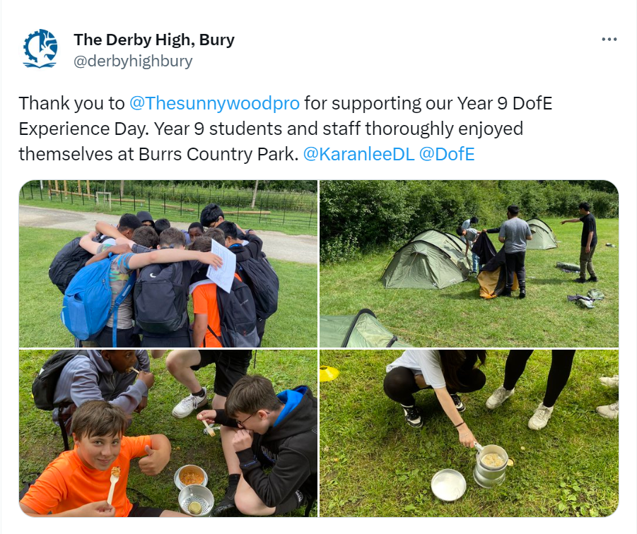
#DOFE
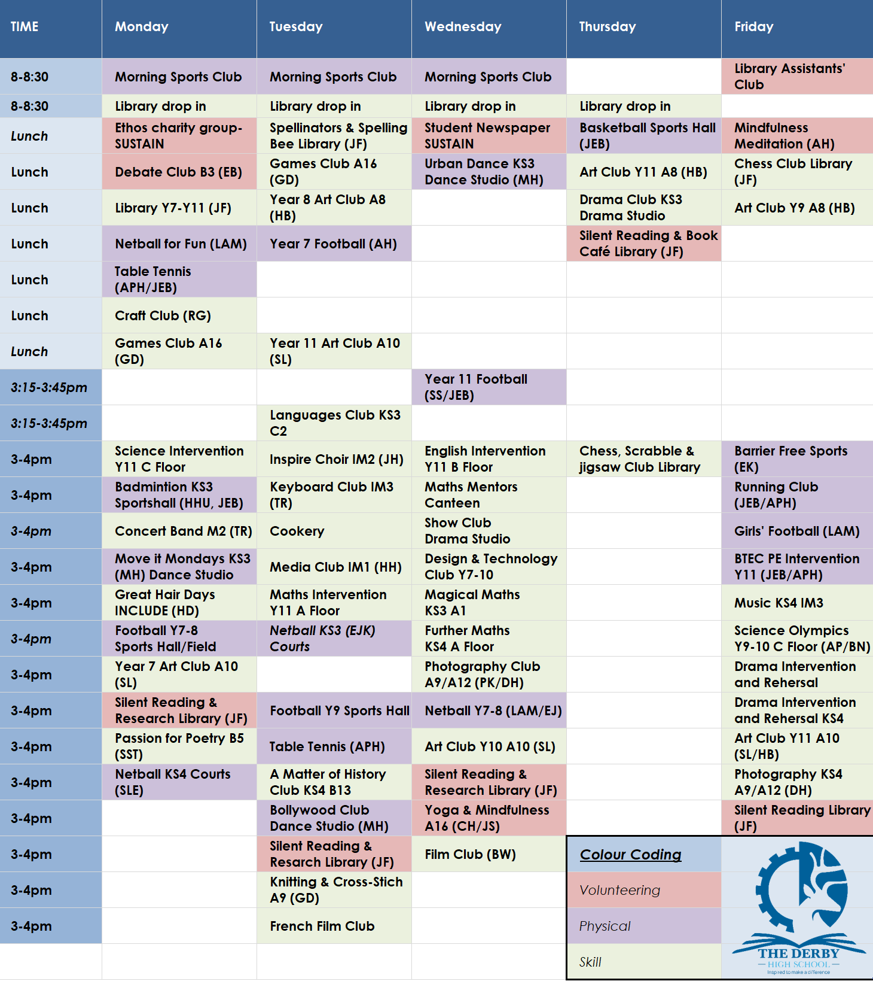
You can download all The Derby Diploma posters and timetable using this LINK

