The Derby High School
Weekly Roundup
WC 19th June 2023

WELL DONE TO OUR BRILLIANT MATHS MENTORS! YOU’VE DONE THE DERBY PROUD

#THEDERBYDIPLOMA

WELL DONE TO OUR YEAR 8 FRENCH AMBASSADORS! YOU WHERE AMAZING
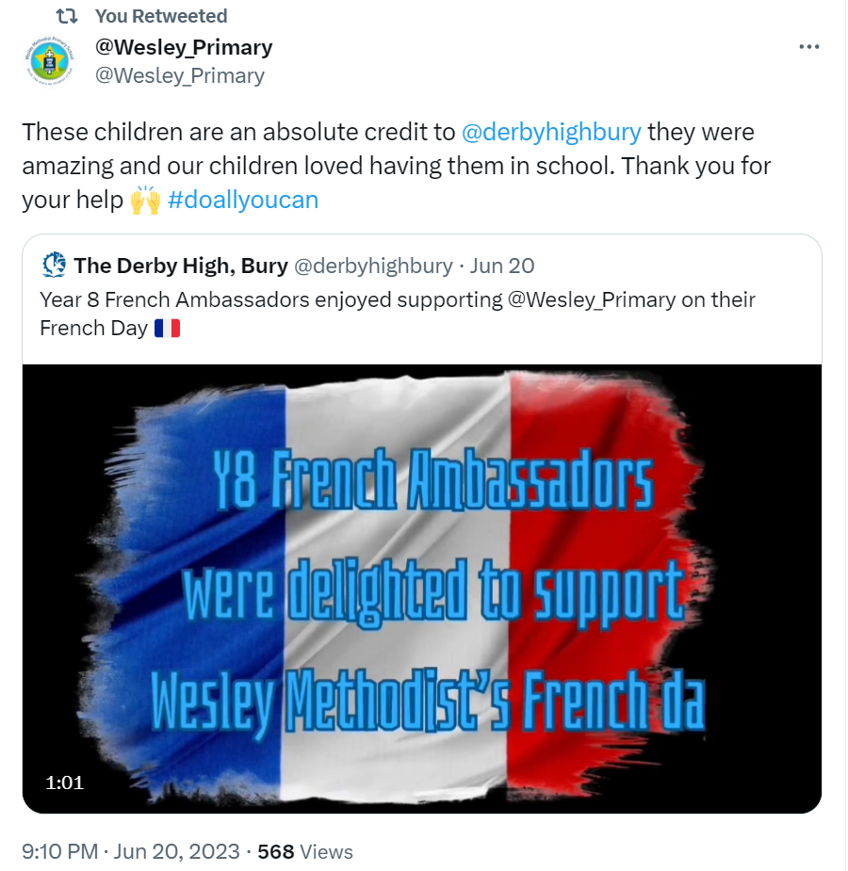
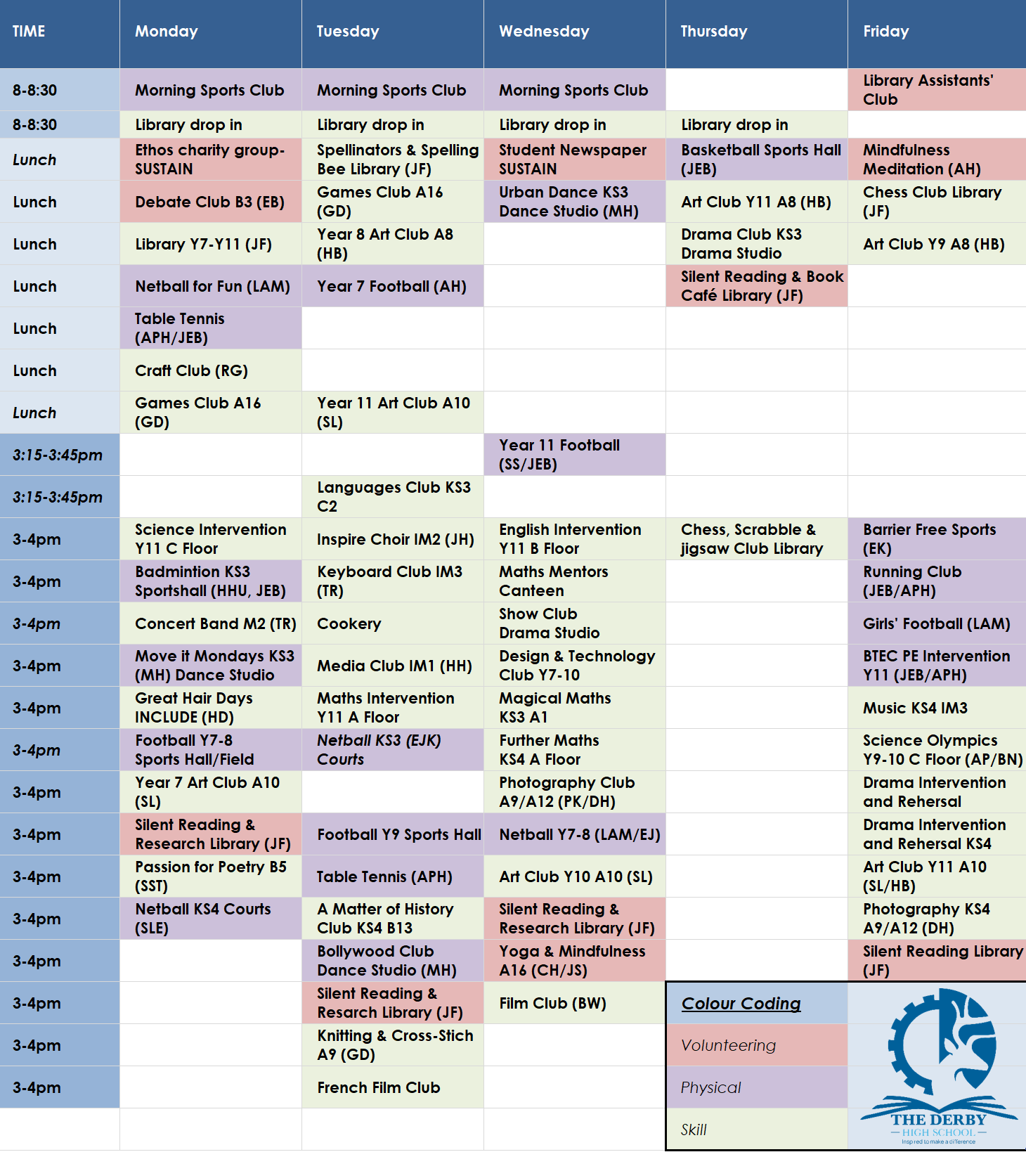
You can download all The Derby Diploma posters and timetable using this LINK

