The Derby High School
Weekly Roundup
WC 5th June 2023

#REALWORLDEXPERIENCES

GET INVOLVED WITH THE DERBY DIPLOMA! THE FULL VIDEO IS AVAILABLE ON OUR TWITTER

WELL DONE BARKLEY!
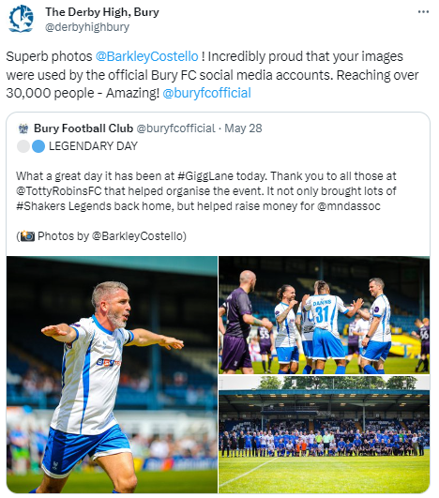
JOIN IN HEALTHY EATING WEEK AT THE DERBY HIGH SCHOOL!

YOU CAN REGISTER HERE:
https://t.co/v2lzFuUvl0
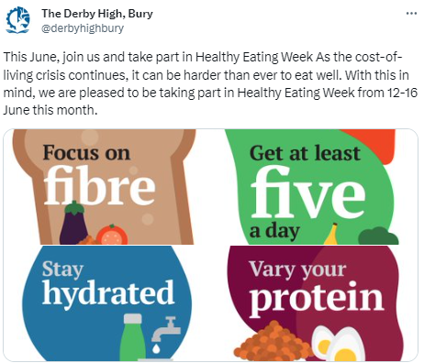

GOOD LUCK TO ALL YEAR 11 STUDENTS IN THEIR GCSE EXAMINATIONS. WE OFFER OUR CONTINUING SUPPORT AND GUIDENCE

#INSPIREDTOMAKEADIFFERENCE
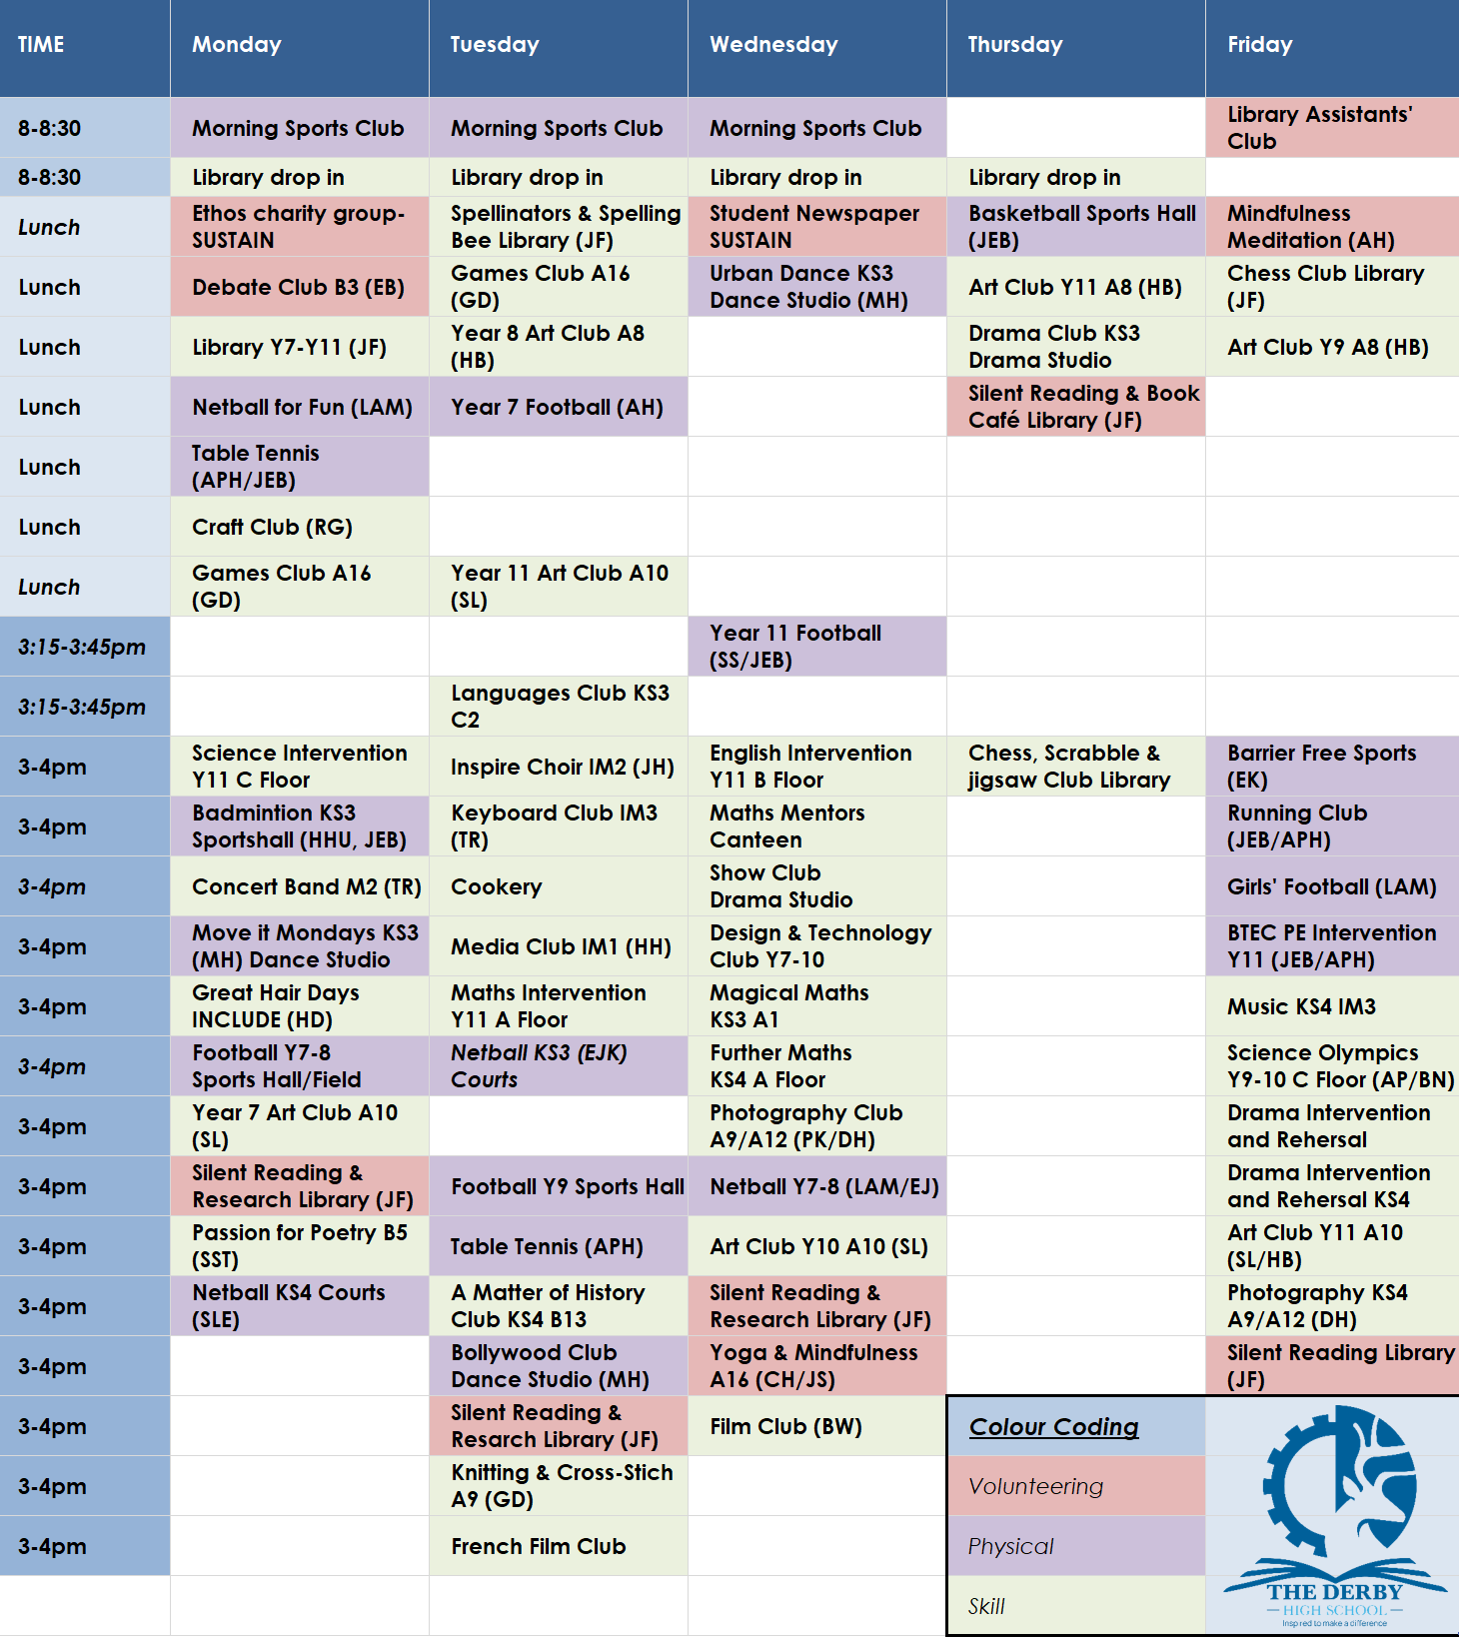
You can download all The Derby Diploma posters and timetable using this LINK

