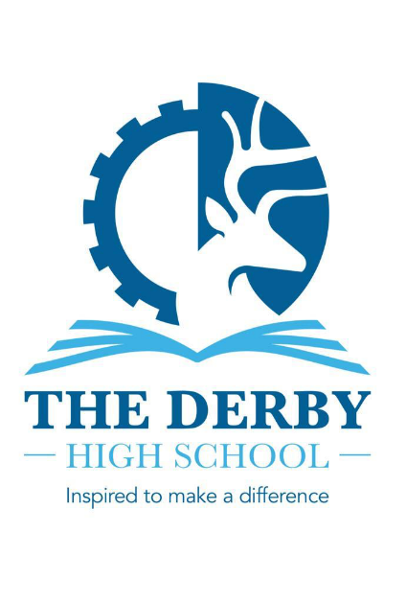

**Information about the English Department**

This post represents a tremendous opportunity for the right applicant. We are seeking to appoint an excellent practitioner to contribute further to our present success within the English Department. Our vision is to provide an engaging and enriching learning environment which promotes a love of English. We do this through our thematic Key Stage 3 curriculum, which interleaves key knowledge and skills, ready for students to embark on their journey to success at Key Stage 4.

The English Department is a collegiate, talented and hardworking team. Achievement in English is strong and teachers have a record of supporting students to achieve excellent outcomes. In 2024, 80% of Year 11 students gained Grade 4+ in English with 69% at Grade 5+. Progress was +0.53.

The Head of English is very well supported by the Second in English and our Lead Practitioner for English. Other key members of the team include a full time, fully-qualified, school librarian, who provides excellent resources and enrichment activities. Teachers have their own classrooms which are based together so there are many opportunities to work collaboratively and all participate in regular subject-specific CPD in Department Meetings.

The teaching of English is further enriched by contributions from our Expressive Arts Department through the delivery of collaborative projects such as the Recall Project where our Key Stage 4 students learn quotations from GCSE texts through Dance and Drama.

Literacy is a growing strength of our school. We also pride ourselves on the broad range of unique opportunities we offer our students as part of The Derby Diploma, including working with writers and artists, taking part in a wide range of competitions and special initiatives to promote and encourage reading. This academic year, for example, Year 11 students have enjoyed a theatre workshop performing A Christmas Carol, Key Stage 3 students have attended Debate Club and Year 7 have visited the theatre to see Animal Farm.

If you are successful in your application, you will be joining a successful and continuously improving team which will provide excellent support and opportunities for the next career stage.